**LOAN TRANSCATION**

--------------------LOAN TRANSCATION--------------------

--------SCD1 AND SCD2------------

------------DESTINATION TABLE TO EXTRACT DATA AND SOURCE TABLE FOR SCD1 AND SCD2-----

**CREATE** **TABLE** [Destination_ANITHA_FA_LOAN] (

[LoanNr_ChkDgt] **float**,

[Name] **nvarchar**(255),

[City] **nvarchar**(255),

[State] **nvarchar**(255),

[Zip] **float**,

[Bank] **nvarchar**(255),

[BankState] **nvarchar**(255),

[NAICS] **float**,

[ApprovalDate] **datetime**,

[ApprovalFY] **float**,

[Term] **float**,

[NoEmp] **float**,

[NewExist] **float**,

[CreateJob] **float**,

[RetainedJob] **float**,

[FranchiseCode] **float**,

[UrbanRural] **float**,

[RevLineCr] **nvarchar**(255),

[LowDoc] **nvarchar**(255),

[ChgOffDate] **datetime**,

[DisbursementDate] **datetime**,

[DisbursementGross] **nvarchar**(255),

[BalanceGross] **nvarchar**(255),

[MIS_Status] **nvarchar**(255),

[ChgOffPrinGr] **nvarchar**(255),

[GrAppv] **nvarchar**(255),

[SBA_Appv] **nvarchar**(255)

)

**SELECT** * **FROM** [Destination_ANITHA_FA_LOAN];

----------------------DESTINATION TABLE FOR SCD1 AND SCD2---------------

**CREATE** **TABLE** [Destination_ANITHA_FA_LOAN1] (

[LoanNr_ChkDgt] **float**,

[Name] **nvarchar**(255),

[City] **nvarchar**(255),

[State] **nvarchar**(255),

[Zip] **float**,

[Bank] **nvarchar**(255),

[BankState] **nvarchar**(255),

[NAICS] **float**,

[ApprovalDate] **datetime**,

[ApprovalFY] **float**,

[Term] **float**,

[NoEmp] **float**,

[NewExist] **float**,

[CreateJob] **float**,

[RetainedJob] **float**,

[FranchiseCode] **float**,

[UrbanRural] **float**,

[RevLineCr] **nvarchar**(255),

[LowDoc] **nvarchar**(255),

[ChgOffDate] **datetime**,

[DisbursementDate] **datetime**,

[DisbursementGross] **nvarchar**(255),

[BalanceGross] **nvarchar**(255),

[MIS_Status] **nvarchar**(255),

[ChgOffPrinGr] **nvarchar**(255),

[GrAppv] **nvarchar**(255),

[SBA_Appv] **nvarchar**(255)

)

**SELECT** * **FROM** [Destination_ANITHA_FA_LOAN1];

**UPDATE** [Destination_ANITHA_FA_LOAN]

**set** Name='anitha',BANK='ANDHRA BANK' **where** LoanNr_ChkDgt=1000014003;

**select** [LoanNr_ChkDgt],[Name],[Bank],[ApprovalDate],[ChgOffDate] **from** [Destination_ANITHA_FA_LOAN1];

--------------AGGREGATE-----------

**SELECT** **MIN**( [NoEmp]) **AS** MIN_NO_EMP,**MAX**( [NoEmp]) **AS** MAX_NO_EMP **FROM** [Destination_ANITHA_FA_LOAN1];

**SCD TYPE 1**

**1. INSERT DATA FROM EXCEL SOURCE TO SQL (LOAN TRANSCATION)**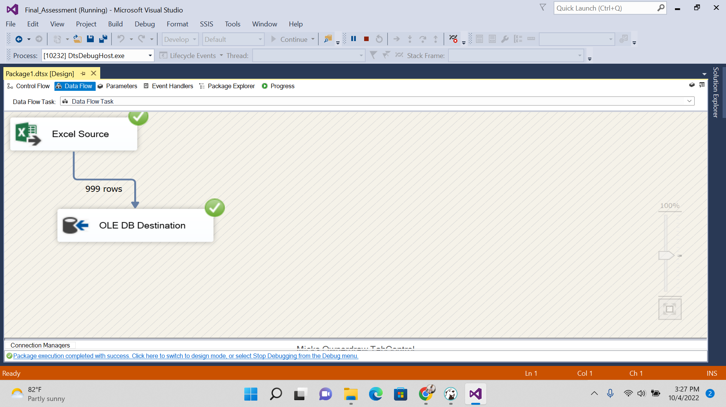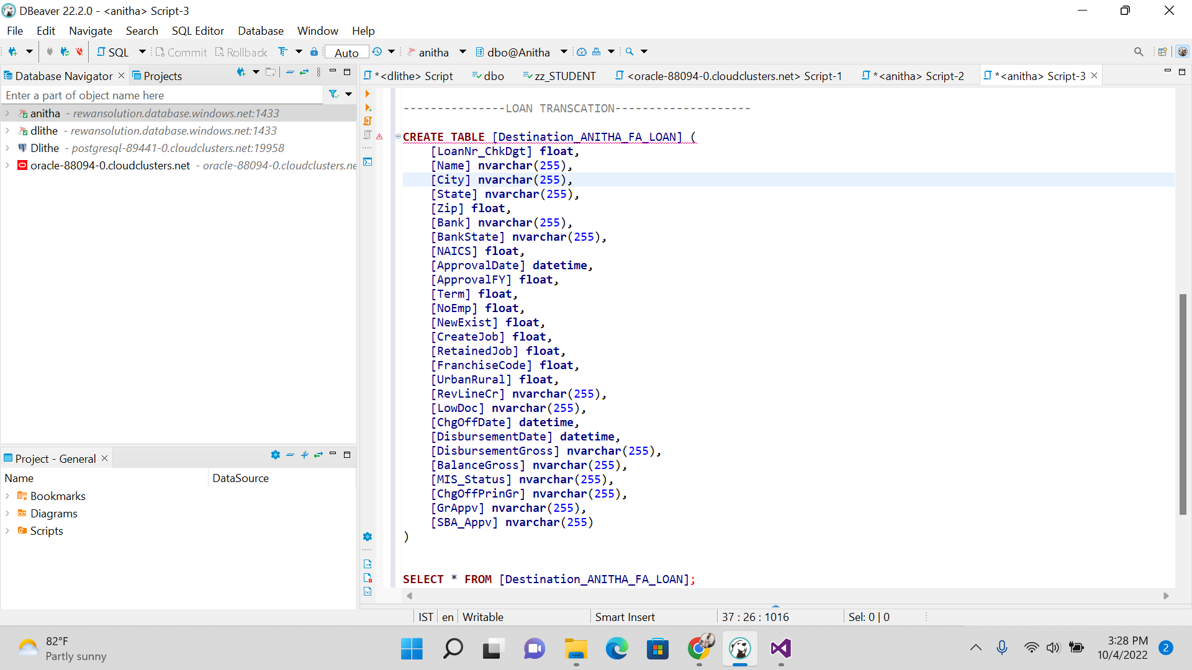

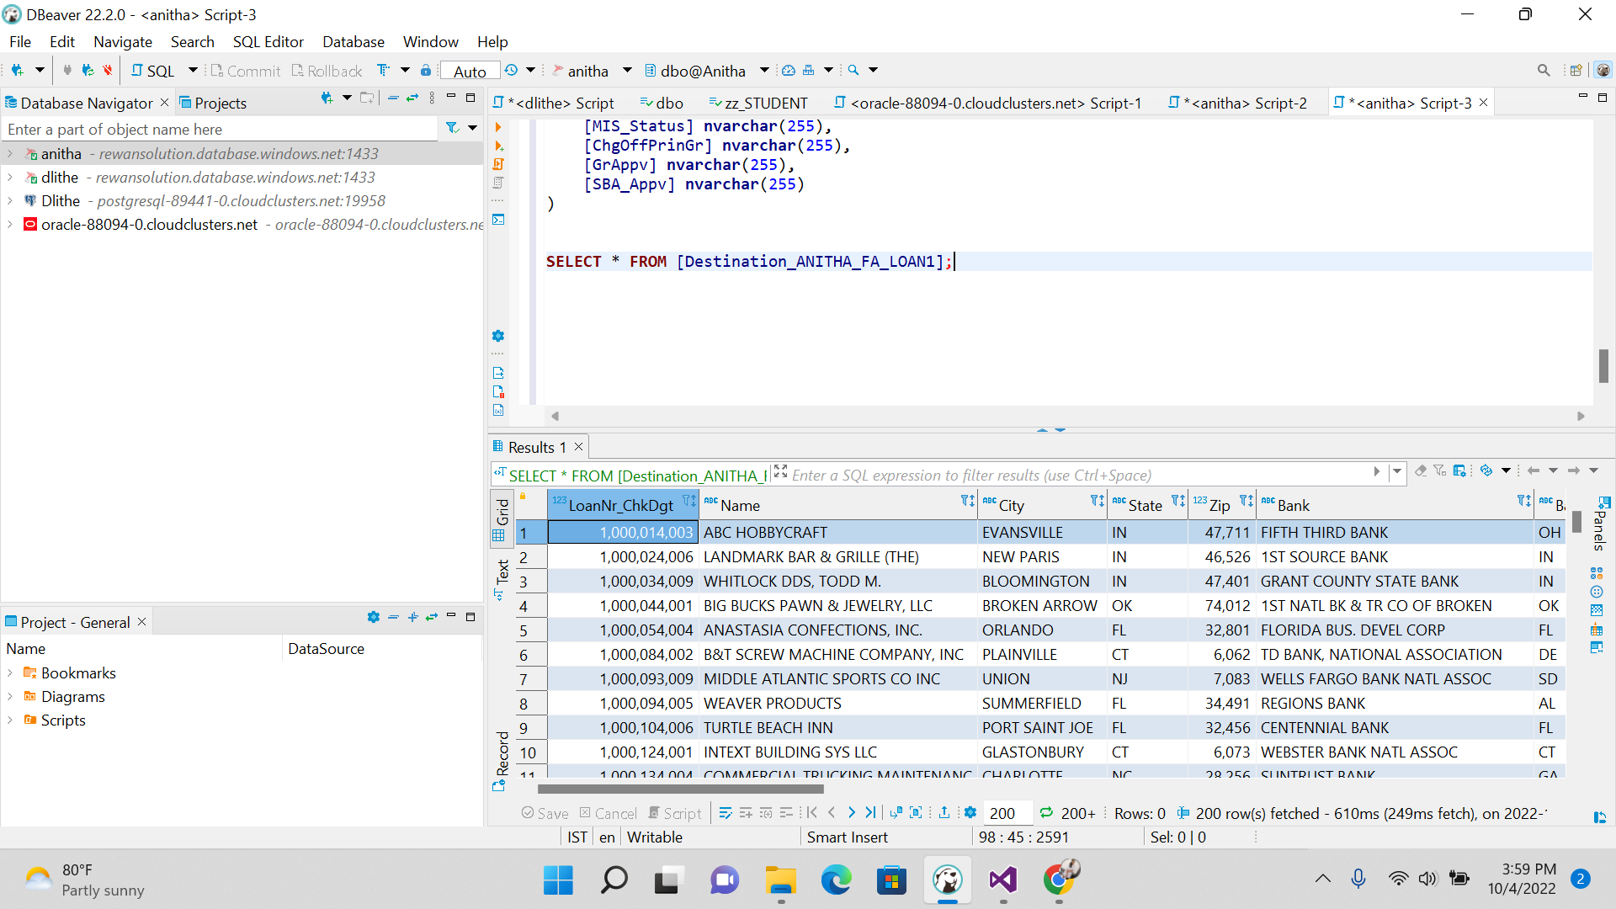

**2.PERFORMING SCD 1 OPERATION BY UPDATING THE VALUE**

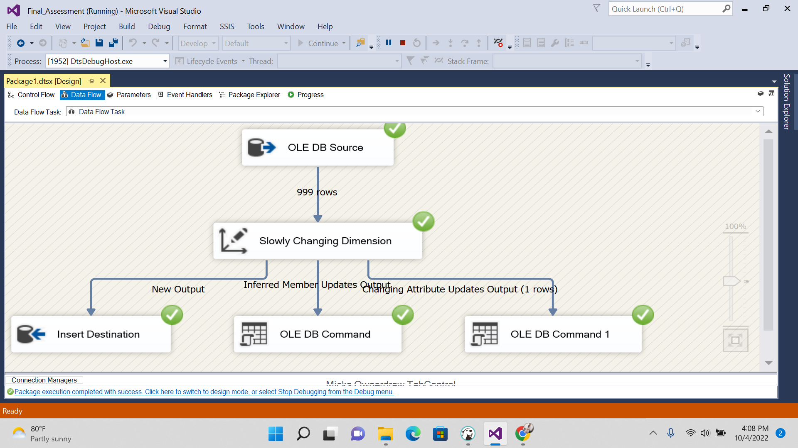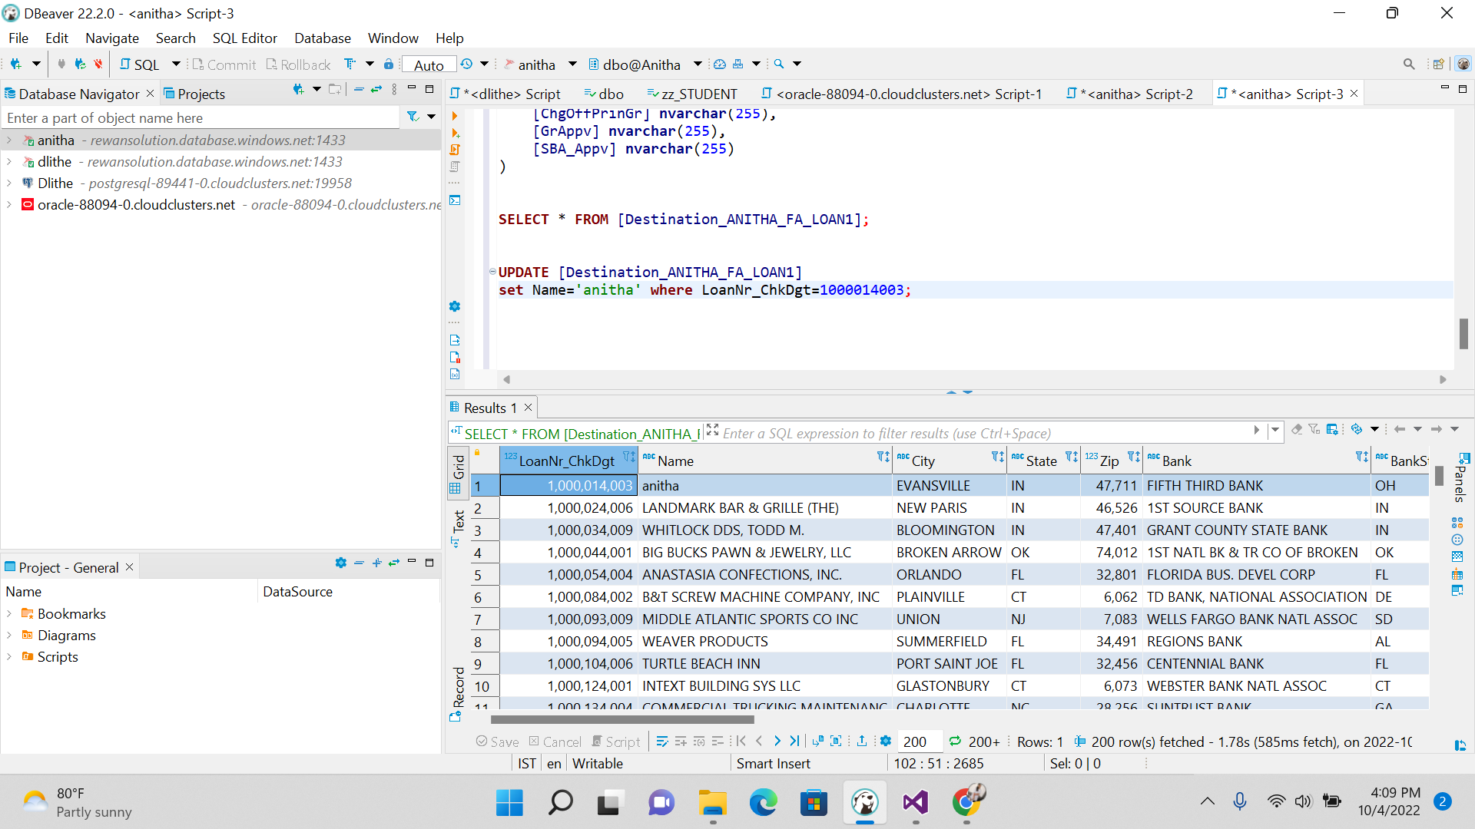

**3. SCD TYPE 2**

**We Get execution result along with historical result.**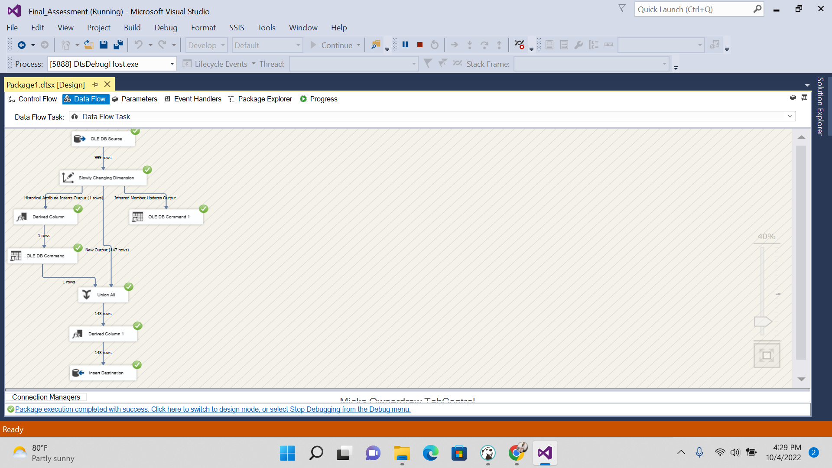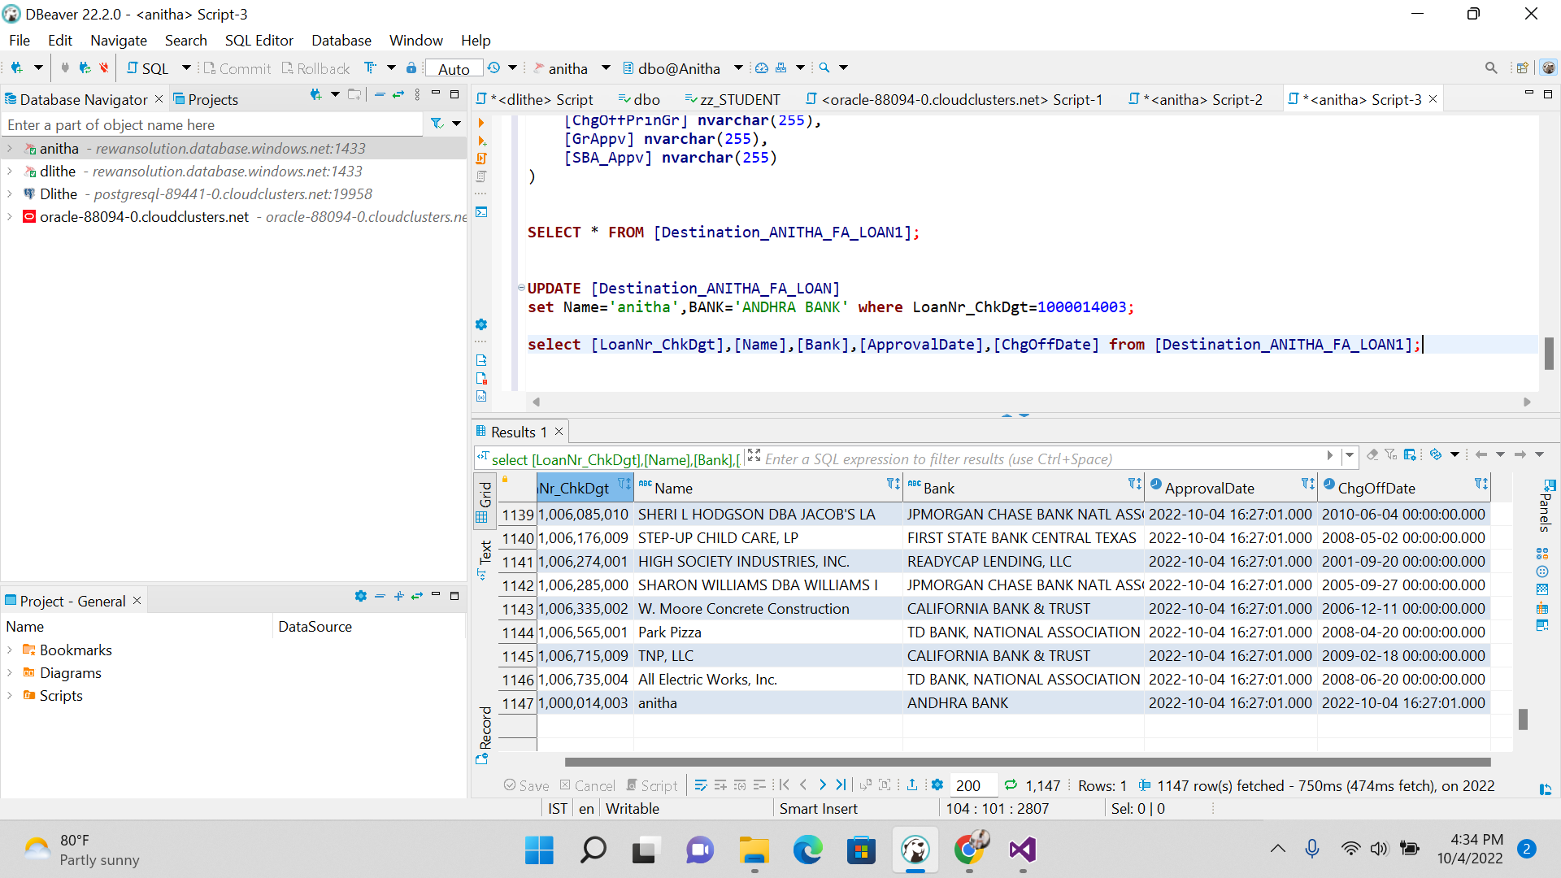

**4.CREATING AGGREGATE BASED ON THE LOAN_NR_DGTCHECK COLUMN**

**-------------------------------------SOURCE TABLE------------------------------------------------**

**CREATE** **TABLE** [ANITHA_EXCEL_DB] (

[LoanNr_ChkDgt] **float**,

[Name] **nvarchar**(255),

[City] **nvarchar**(255),

[State] **nvarchar**(255),

[Zip] **float**,

[Bank] **nvarchar**(255),

[BankState] **nvarchar**(255),

[NAICS] **float**,

[ApprovalDate] **datetime**,

[ApprovalFY] **float**

)

**SELECT** * **FROM** [ANITHA_EXCEL_DB];

**--------------------------- AGGREGATE FUNCTION STEPS -------------------------------**

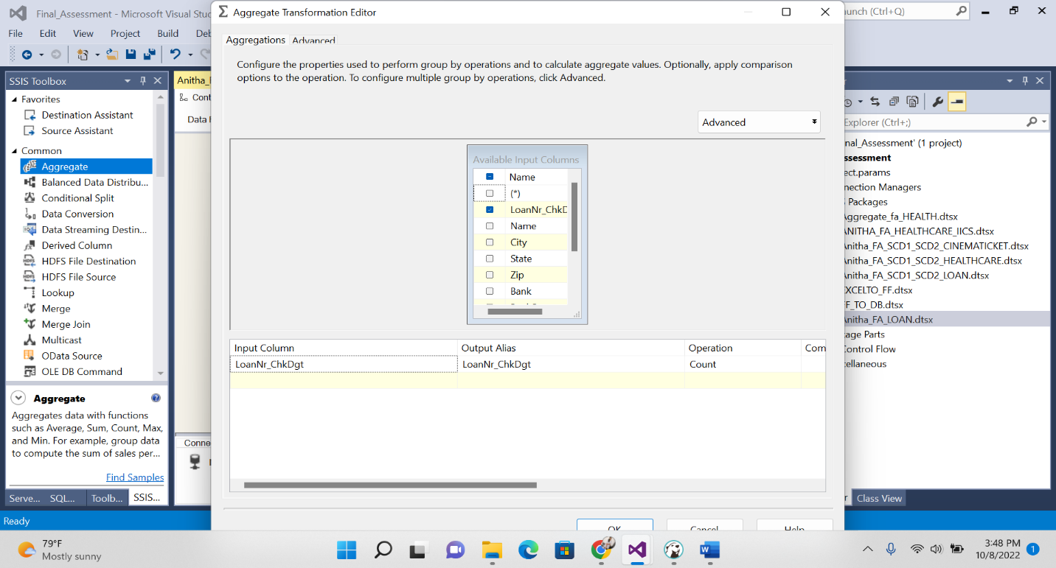

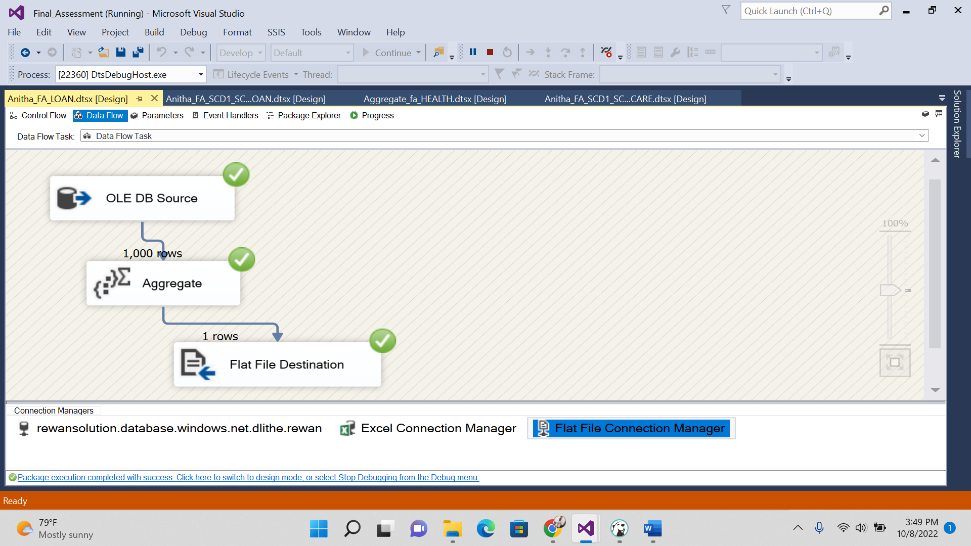

**-------------------------------------- FINAL OUTPUT IN FLAT FILE --------------------------------**

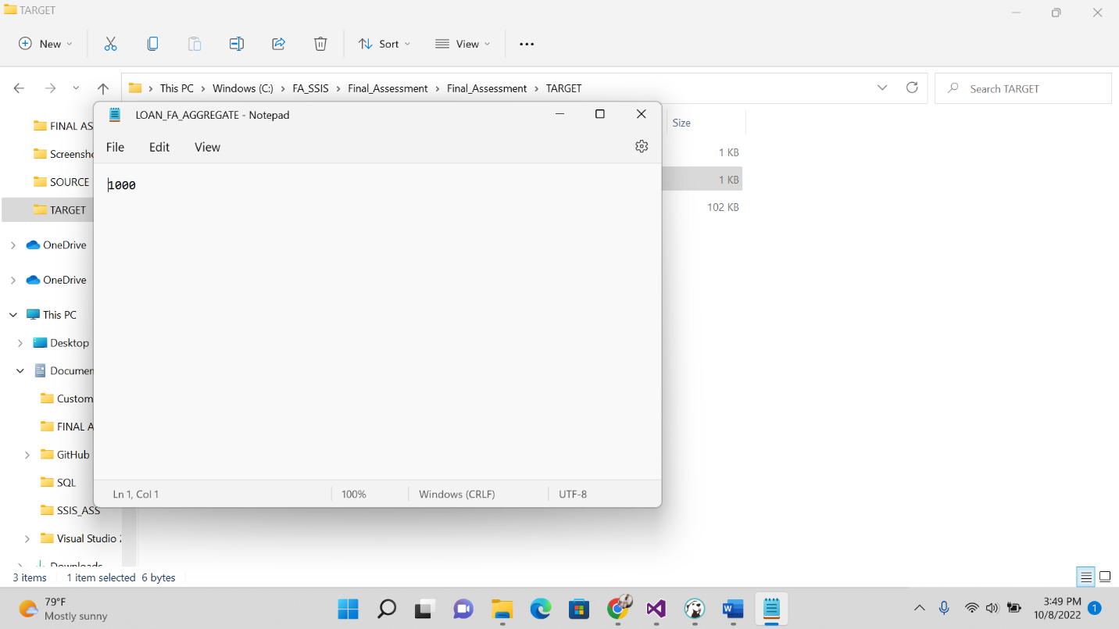

**HEALTH CARE**

-----------SOURCE WILL BE EXCEL SHEET AND EXCEL SHEET TO FLAT FILE -----------------

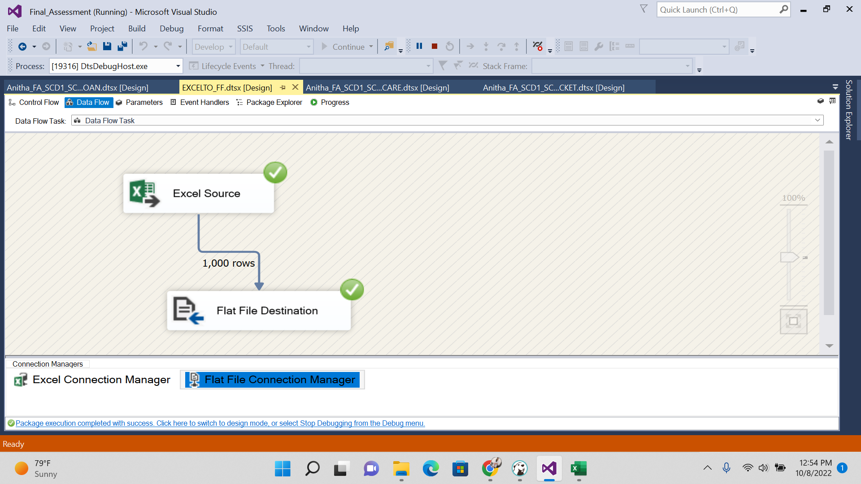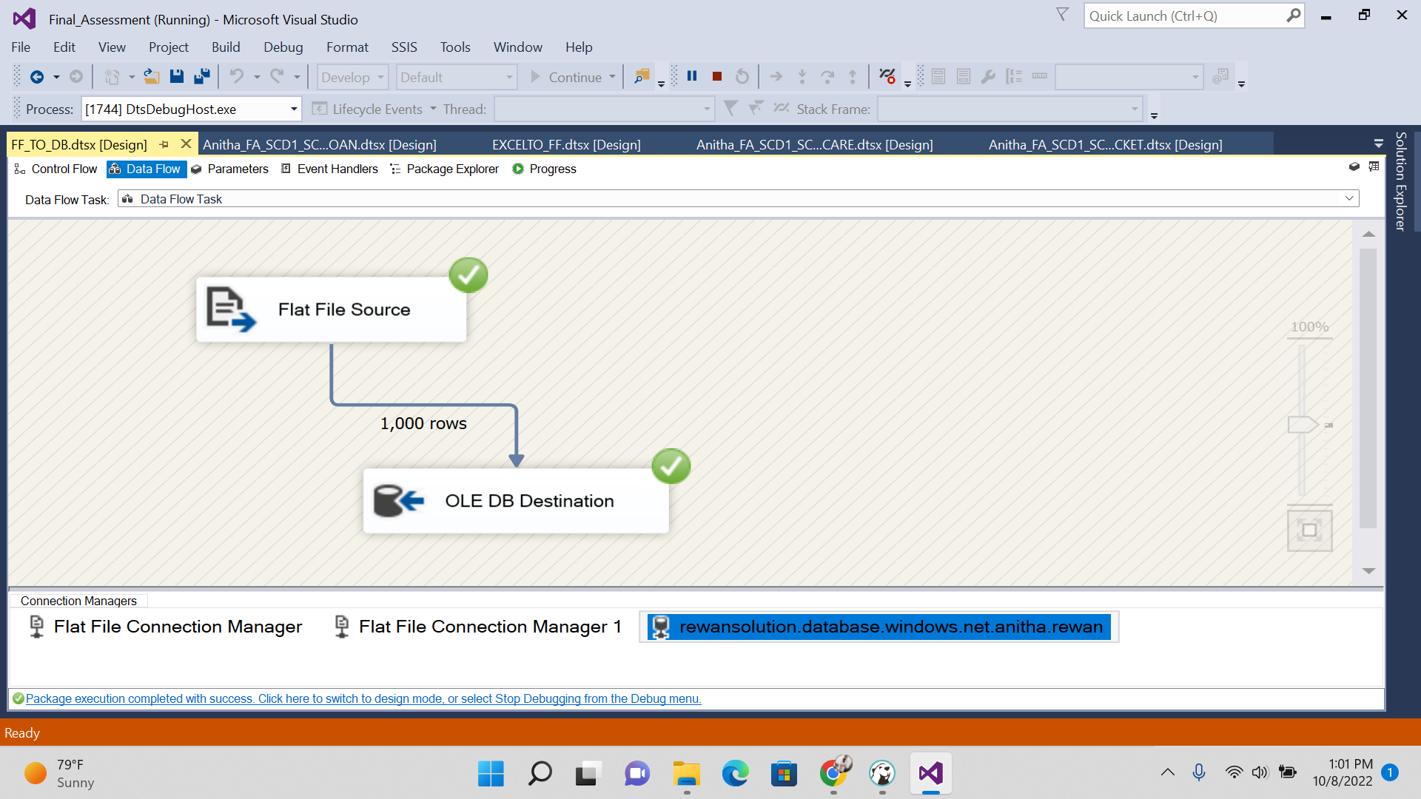

----------------DESTINATION TABLE---------------------

**CREATE** **TABLE** [ANITHA_FA_SSIS_HEALTHCARE] (

[PID] **float**,

[AGE] **float**,

[GENDER] **nvarchar**(255),

[CASTE_NAME] **nvarchar**(255),

[CATEGORY_CODE] **nvarchar**(255),

[CATEGORY_NAME] **nvarchar**(255),

[SURGERY_CODE] **nvarchar**(255),

[SURGERY] **nvarchar**(255),

[VILLAGE] **nvarchar**(255),

[MANDAL_NAME] **nvarchar**(255),

[DISTRICT_NAME] **nvarchar**(255),

[PREAUTH_DATE] **datetime**,

[PREAUTH_AMT] **float**,

[CLAIM_DATE] **datetime**,

[CLAIM_AMOUNT] **float**,

[HOSP_NAME] **nvarchar**(255),

[HOSP_TYPE] **nvarchar**(255),

[HOSP_DISTRICT] **nvarchar**(255),

[SURGERY_DATE] **datetime**,

[DISCHARGE_DATE] **datetime**,

[Mortality Y / N] **nvarchar**(255),

[MORTALITY_DATE] **datetime**,

[SRC_REGISTRATION] **nvarchar**(255)

);

**SELECT** * **FROM** [ANITHA_FA_SSIS_HEALTHCARE];

-----------------------TARGET FOR SCD1 AND SCD2----------------------

**CREATE** **TABLE** [ANITHA_FA_SSIS_HEALTHCARE_SCD1_SCD2_TGT] (

[PID] **float**,

[AGE] **float**,

[GENDER] **nvarchar**(255),

[CASTE_NAME] **nvarchar**(255),

[CATEGORY_CODE] **nvarchar**(255),

[CATEGORY_NAME] **nvarchar**(255),

[SURGERY_CODE] **nvarchar**(255),

[SURGERY] **nvarchar**(255),

[VILLAGE] **nvarchar**(255),

[MANDAL_NAME] **nvarchar**(255),

[DISTRICT_NAME] **nvarchar**(255),

[PREAUTH_DATE] **datetime**,

[PREAUTH_AMT] **float**,

[CLAIM_DATE] **datetime**,

[CLAIM_AMOUNT] **float**,

[HOSP_NAME] **nvarchar**(255),

[HOSP_TYPE] **nvarchar**(255),

[HOSP_DISTRICT] **nvarchar**(255),

[SURGERY_DATE] **datetime**,

[DISCHARGE_DATE] **datetime**,

[Mortality Y / N] **nvarchar**(255),

[MORTALITY_DATE] **datetime**,

[SRC_REGISTRATION] **nvarchar**(255)

);

**SELECT** * **FROM** [ANITHA_FA_SSIS_HEALTHCARE_SCD1_SCD2_TGT];

----------------------------FOR SCD1--------------------

**UPDATE** [ANITHA_FA_SSIS_HEALTHCARE]

**SET** DISTRICT_NAME='BALLARI' **WHERE** PID=1;

**SELECT** PID,CASTE_NAME,DISTRICT_NAME,MANDAL_NAME,SURGERY **FROM**[ANITHA_FA_SSIS_HEALTHCARE_SCD1_SCD2_TGT];

------------------FOR SCD2-------------------

**UPDATE** [ANITHA_FA_SSIS_HEALTHCARE]

**SET** DISTRICT_NAME='BALLARI',MANDAL_NAME='KOLLAGALLU',VILLAGE='kRISHNANAGAR' **WHERE** PID=1;

**SELECT** PID,CASTE_NAME,DISTRICT_NAME,MANDAL_NAME,VILLAGE,CLAIM_DATE,SURGERY_DATE **FROM**[ANITHA_FA_SSIS_HEALTHCARE_SCD1_SCD2_TGT];

--------------------AGGREGATE-------------

**SELECT** **COUNT**(PID) **AS** PID_COUNT **FROM** [ANITHA_FA_SSIS_HEALTHCARE_SCD1_SCD2_TGT];

**SCD TYPE 1**

**1.INSERT DATA FROM EXCEL SOURCE TO SQL(HEALTHCARE_SURGERY)**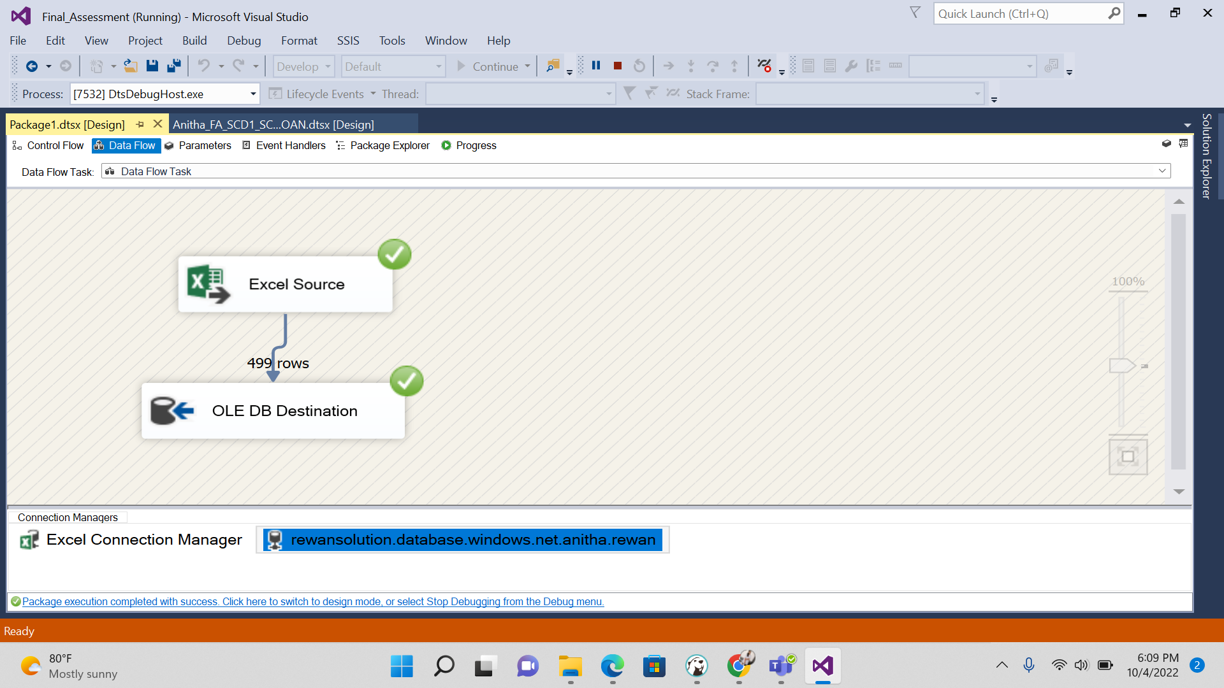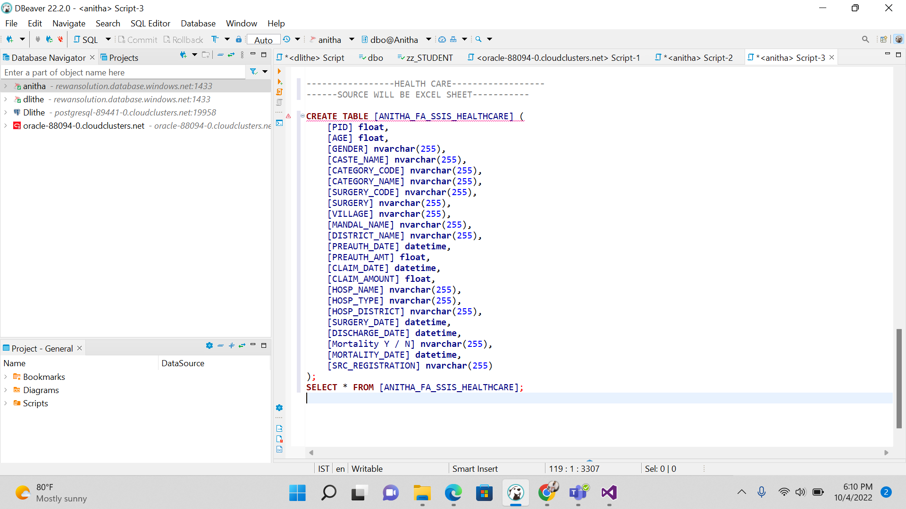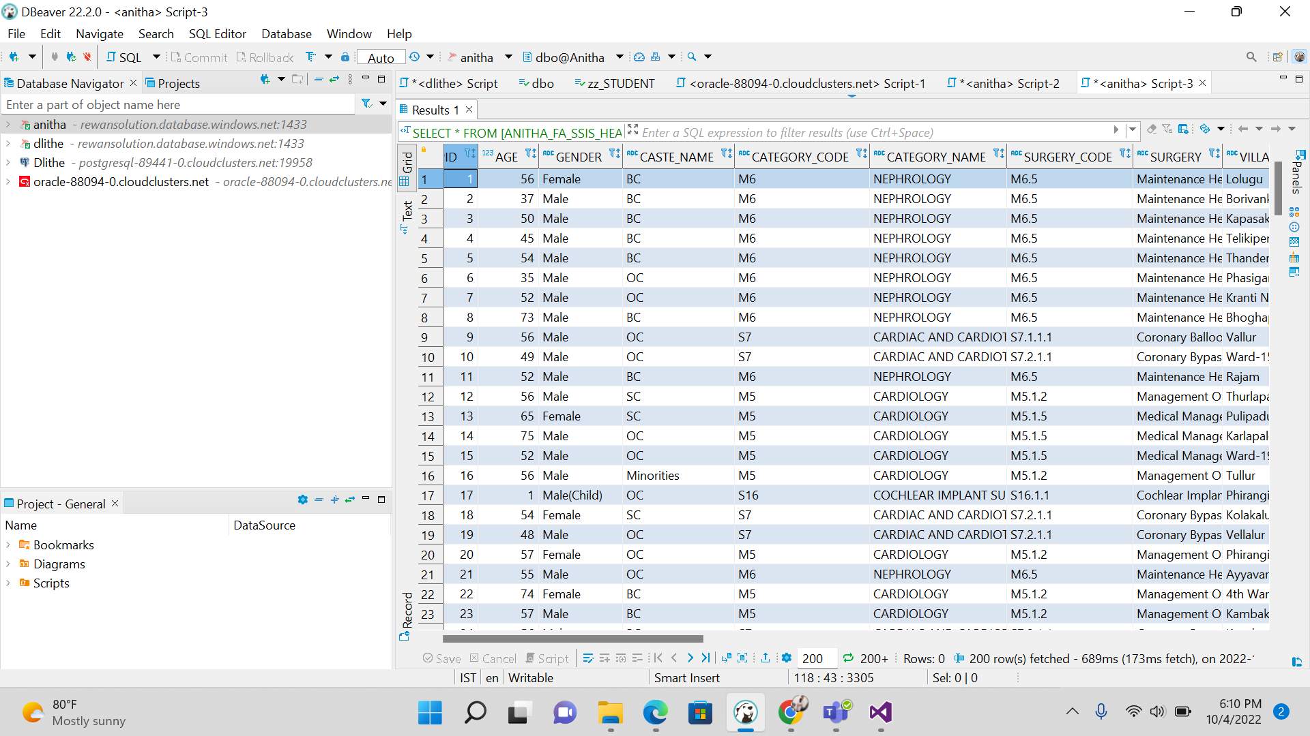

**2.PERFORMING SCD 1 OPERATION BY UPDATING THE VALUE**

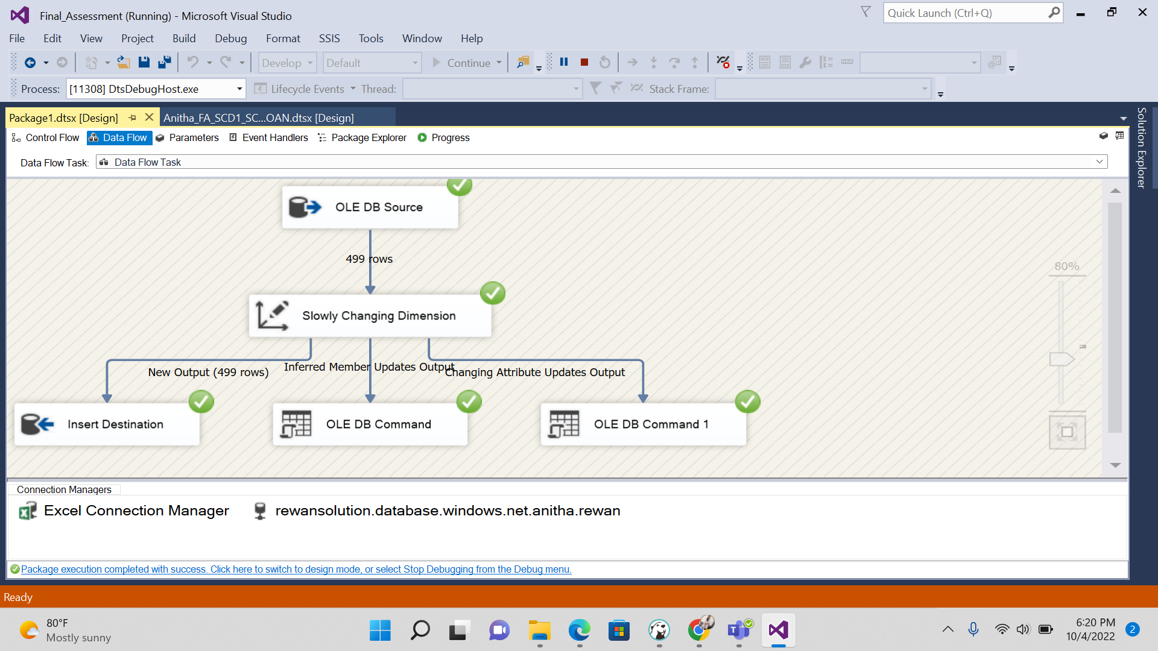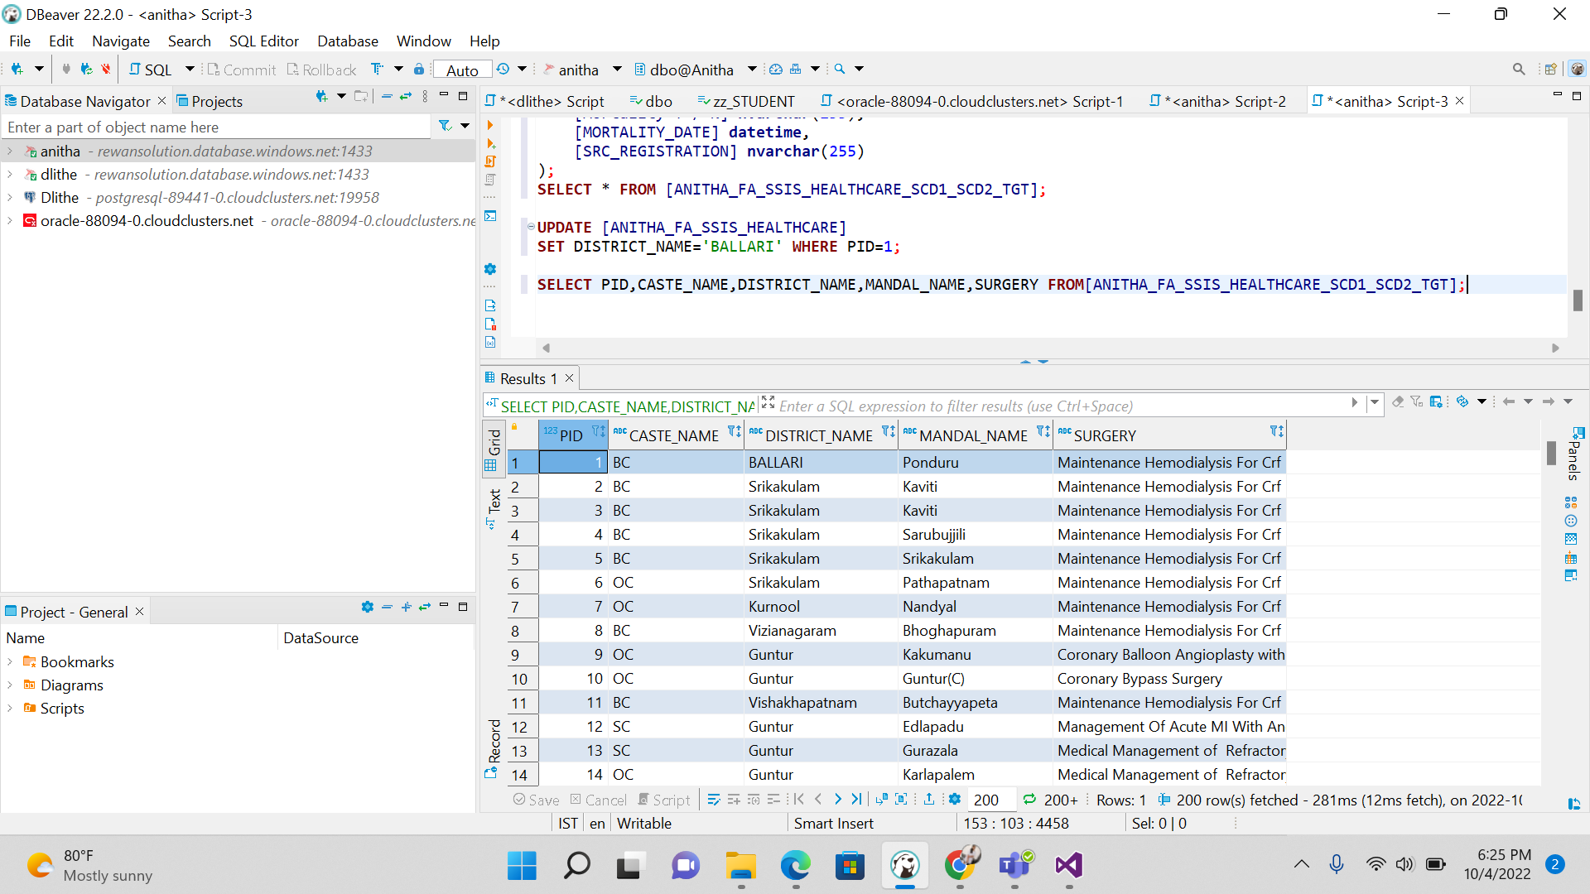

**3. SCD TYPE 2**

**We Get execution result along with historical result.**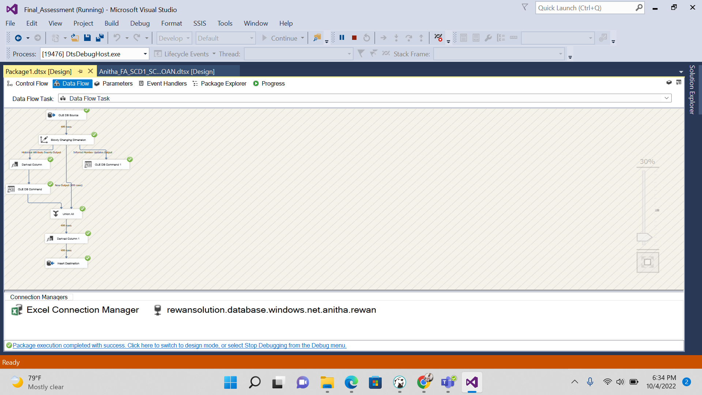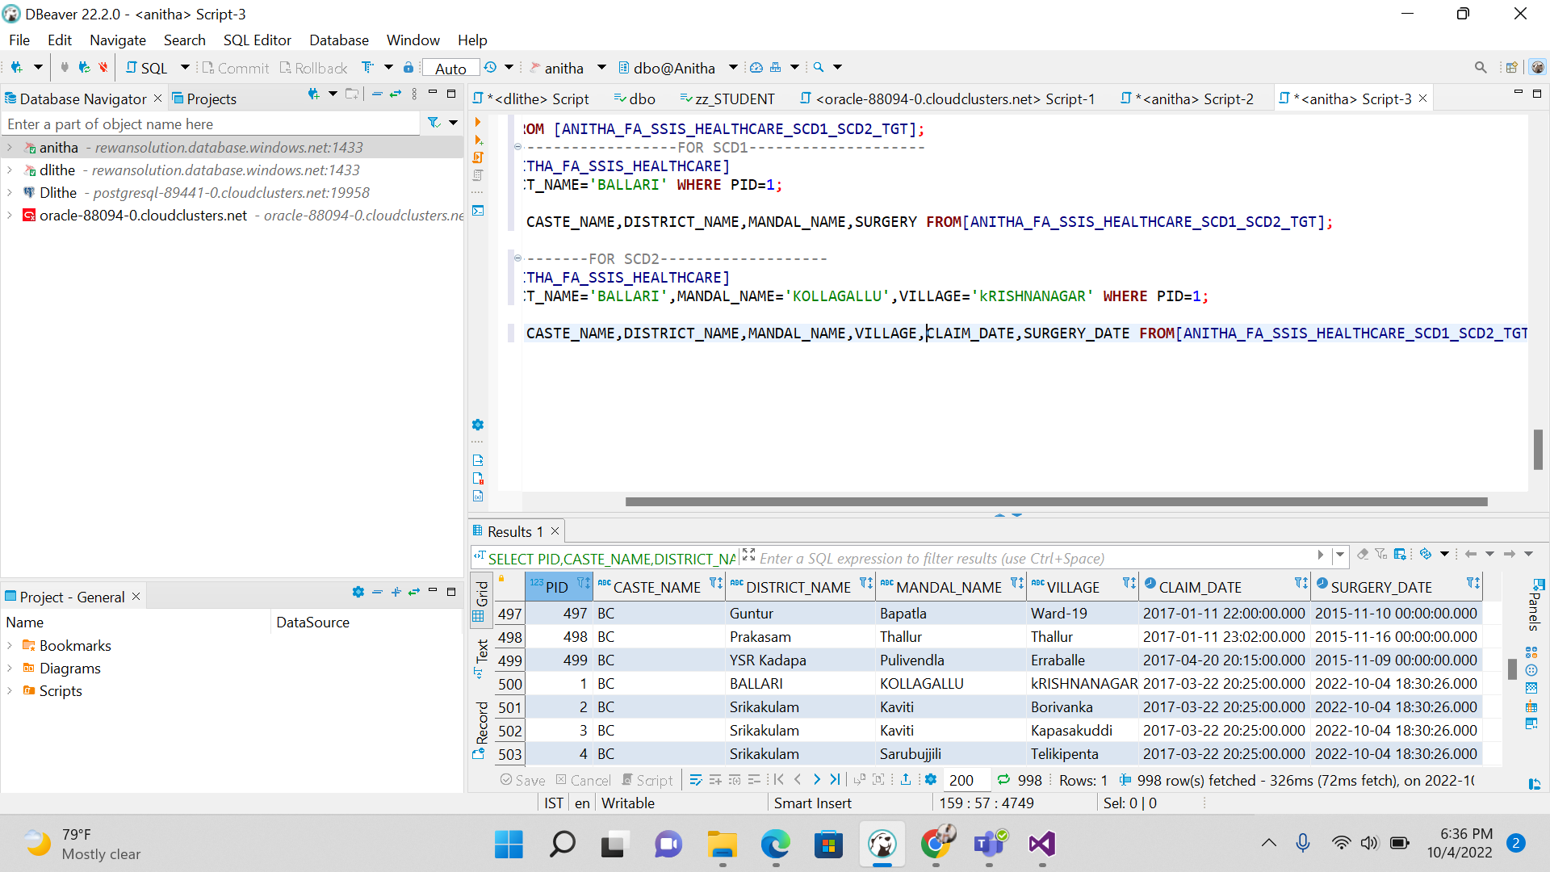

**4.CREATING AGGREGATE BASED ON THE CLAIM AMOUNT COLUMN**

**-------SOURCE TABLE---------**

**CREATE** **TABLE** [ANITHA_IICS_FA_HC_TGT] (

[PID] **float**,

[AGE] **float**,

[GENDER] **nvarchar**(25),

[CATEGORY_NAME] **nvarchar**(25),

[DISTRICT_NAME] **nvarchar**(25),

[PREAUTH_AMT] **float**,

[CLAIM_AMOUNT] **float**,

[HOSP_NAME] **nvarchar**(25),

[SURGERY_DATE] **datetime**,

[DISCHARGE_DATE] **datetime**

);

**SELECT** * **FROM** [ANITHA_IICS_FA_HC_TGT];

-------------------DESTINATION IS FLAT FILE--------------------------------

---------------------AGGREGATE STEPS----------------------------

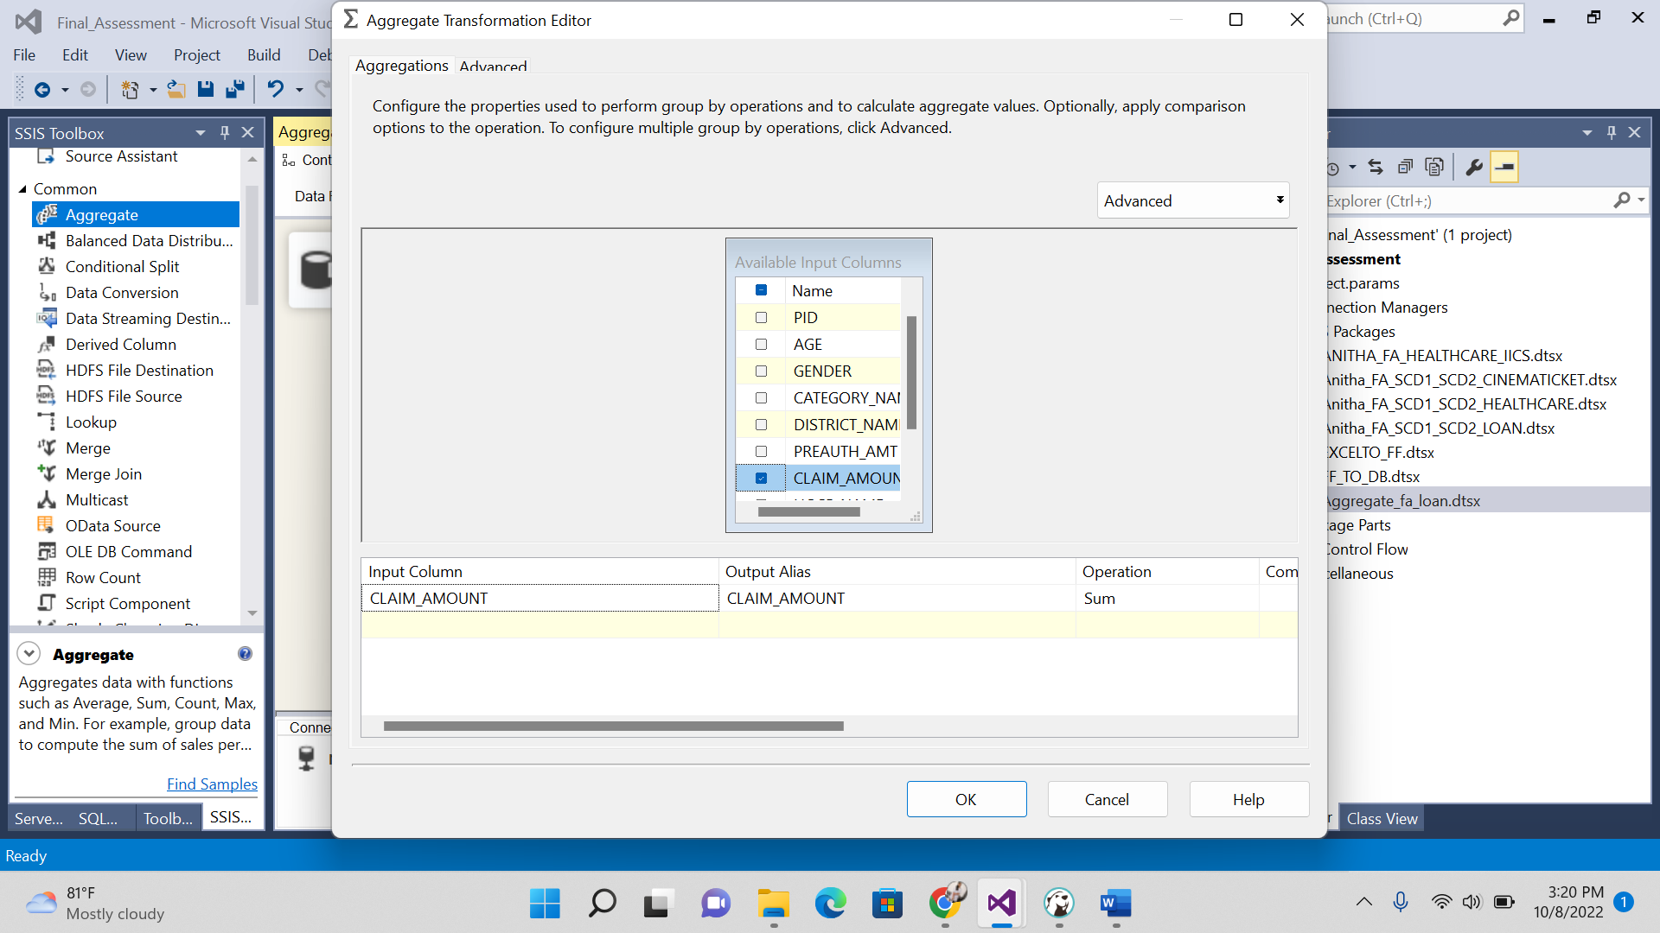

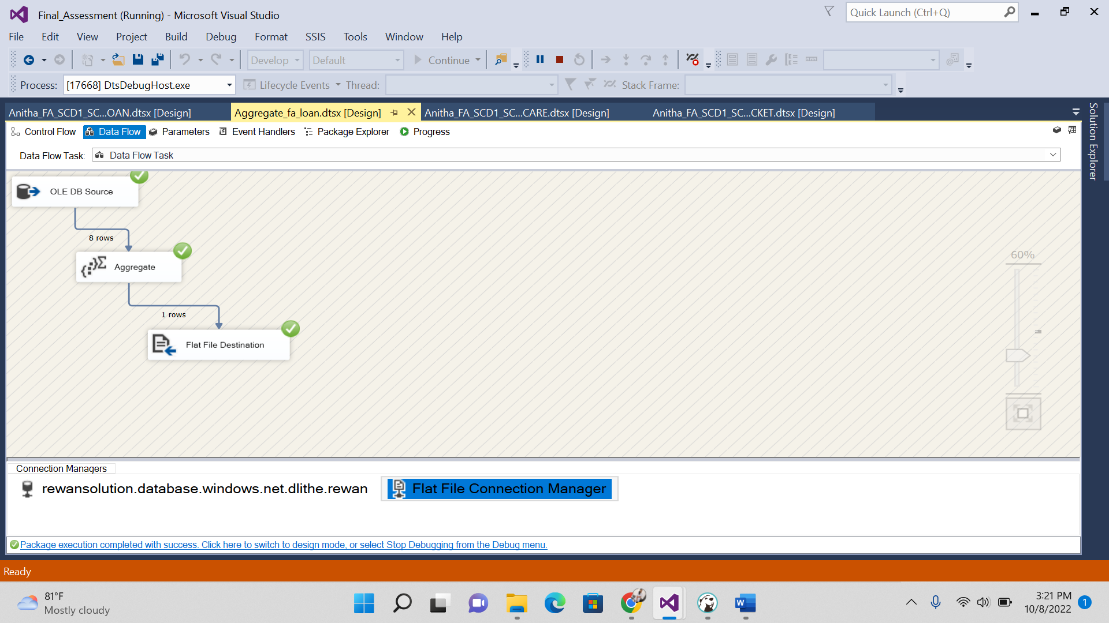

**---------------------------------FINAL OUTPUT IN FLATFILE--------------------**

**Here I am checking with sum of claim amount**

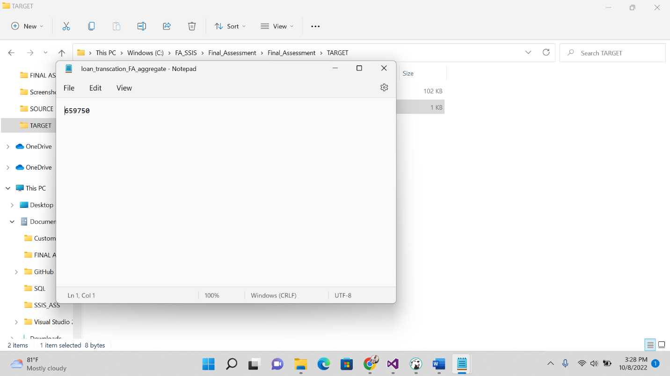

------------------------------CINEMA TICKET--------------------------

---------------------------SOURCE WILL BE EXCEL SHEET----------------

----------------DESTINATION TABLE AND SOURCE TABLE FOR SCD 1 AND SCD2---------------------

**CREATE** **TABLE** [ANITHA_FA_SSIS_CINEMA_TICKET] (

[Film_Type] **nvarchar**(255),

[film_code] **float**,

[cinema_code] **float**,

[total_sales] **float**,

[tickets_sold] **float**,

[tickets_out] **float**,

[show_time] **float**,

[occu_perc] **float**,

[ticket_price] **float**,

[ticket_use] **float**,

[capacity] **float**,

[date] **datetime**,

[month] **float**,

[quarter] **float**,

[day] **float**

);

**SELECT** * **FROM** [ANITHA_FA_SSIS_CINEMA_TICKET];

----------------------TARGET TABLE FOR SCD1 AND SCD2-------------------

**CREATE** **TABLE** [ANITHA_FA_SSIS_CINEMA_TICKET_SCD1_SCD2_TGT] (

[Film_Type] **nvarchar**(255),

[film_code] **float**,

[cinema_code] **float**,

[total_sales] **float**,

[tickets_sold] **float**,

[tickets_out] **float**,

[show_time] **float**,

[occu_perc] **float**,

[ticket_price] **float**,

[ticket_use] **float**,

[capacity] **float**,

[date] **datetime**,

[end_date] **datetime**,

[month] **float**,

[quarter] **float**,

[day] **float**

);

**SELECT** * **FROM** [ANITHA_FA_SSIS_CINEMA_TICKET_SCD1_SCD2_TGT];

**drop** **table** [ANITHA_FA_SSIS_CINEMA_TICKET_SCD1_SCD2_TGT];

--------------------PERFORMING SCD1 BY UPDATING THE VALUES------------

**UPDATE** [ANITHA_FA_SSIS_CINEMA_TICKET]

**SET** Film_Type='HORROR THRILLER' **WHERE** **day**=5;

**select** film_type,film_code,**day**,ticket_price **from** [ANITHA_FA_SSIS_CINEMA_TICKET_SCD1_SCD2_TGT];

--------------------PERFORMING SCD2 BY UPDATING THE VALUES------------

**UPDATE** [ANITHA_FA_SSIS_CINEMA_TICKET]

**SET** Film_Type='HORROR THRILLER',film_code=15000 **WHERE** **day**=5;

**select** film_type,film_code,**day**,ticket_price **from** [ANITHA_FA_SSIS_CINEMA_TICKET_SCD1_SCD2_TGT];

------------------------------AGGREGATE-------------------------------

**SELECT** **COUNT**(**DAY**) **AS** NO_DAYS **FROM** [ANITHA_FA_SSIS_CINEMA_TICKET_SCD1_SCD2_TGT];

**SCD TYPE 1**

**1.INSERT DATA FROM EXCEL SOURCE TO SQL(CINEMA TICKET)**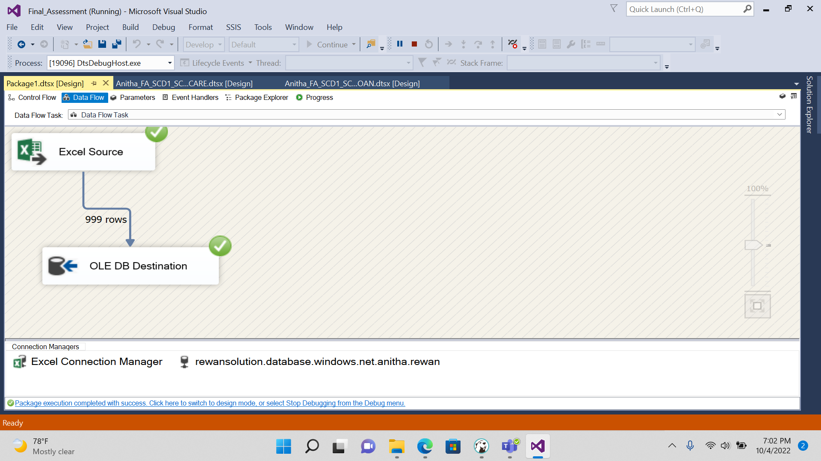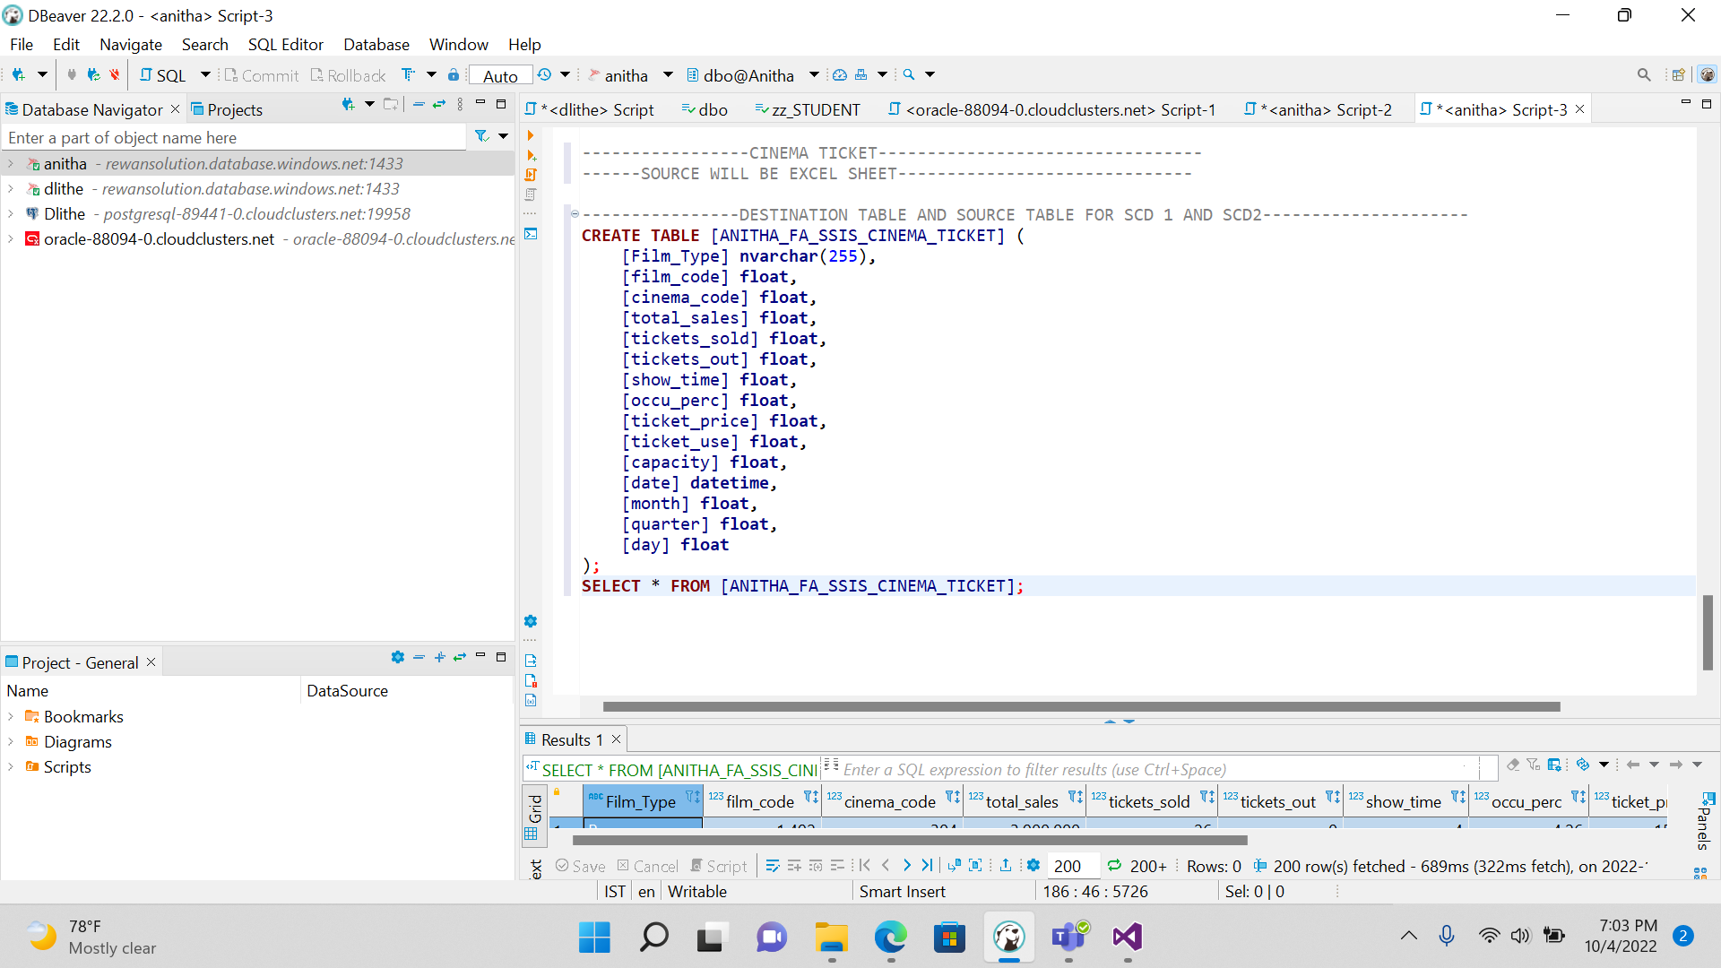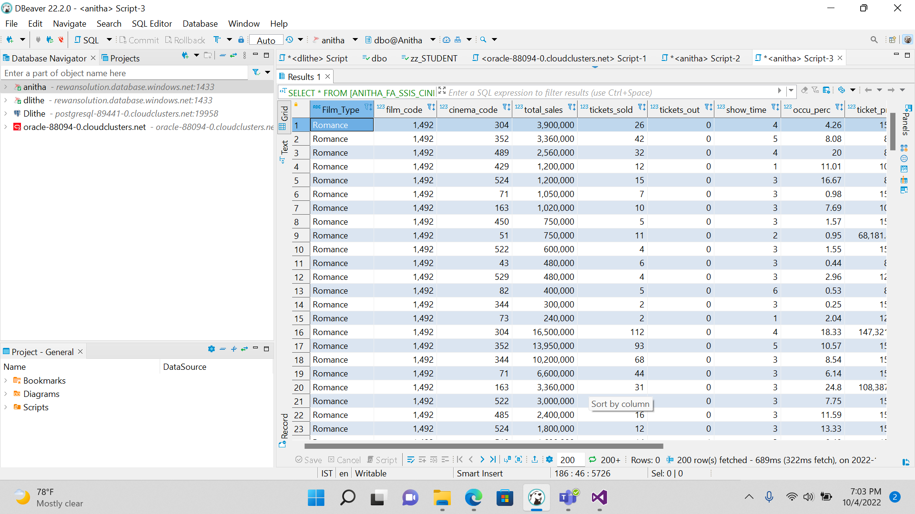

**2.PERFORMING SCD 1 OPERATION BY UPDATING THE VALUE**

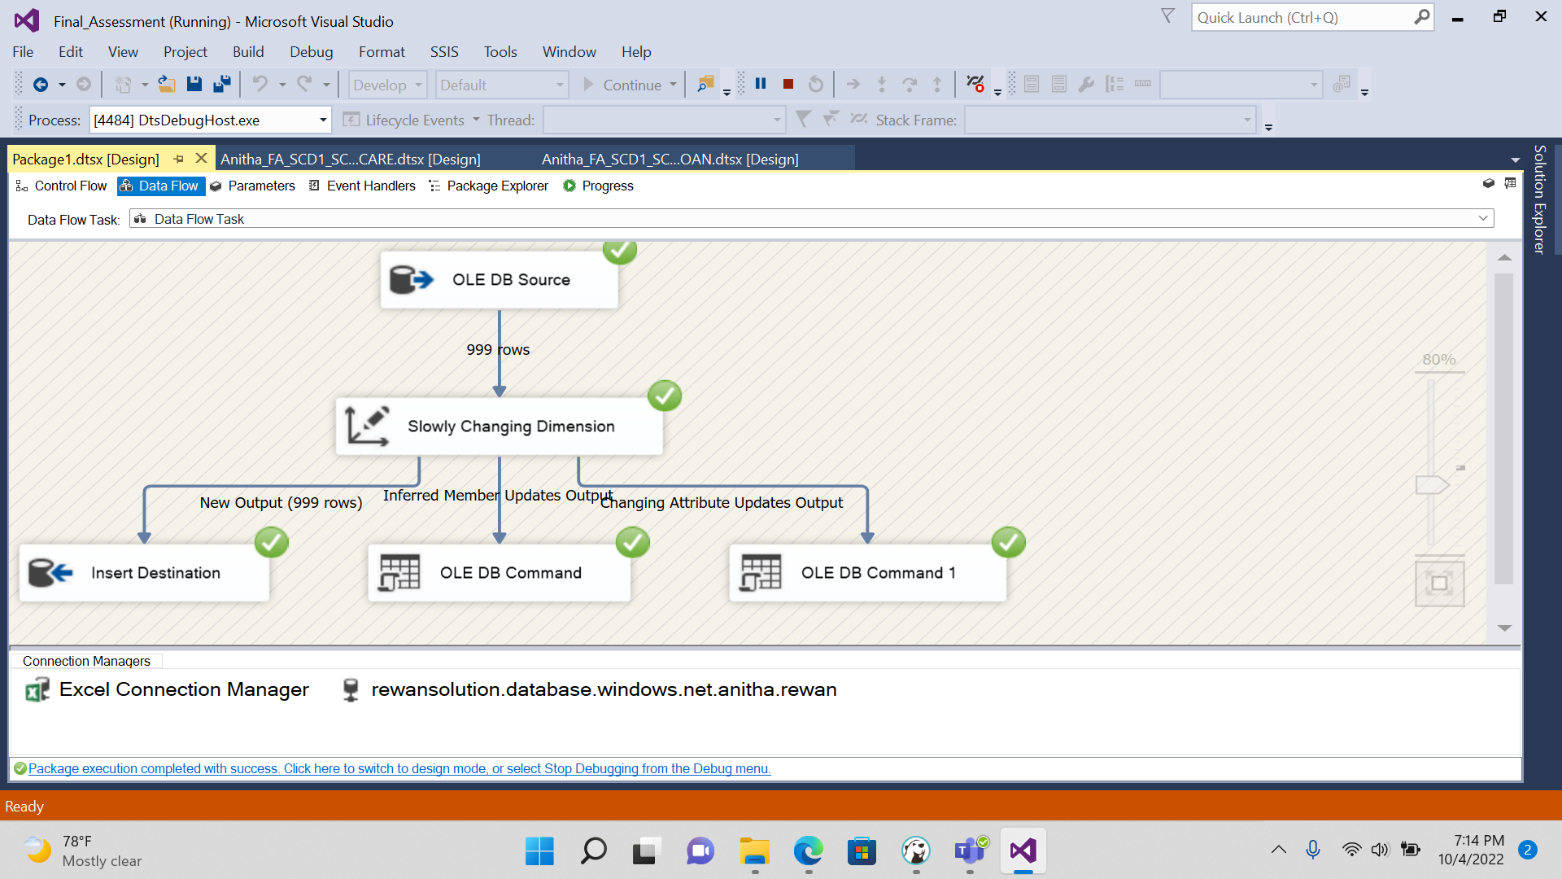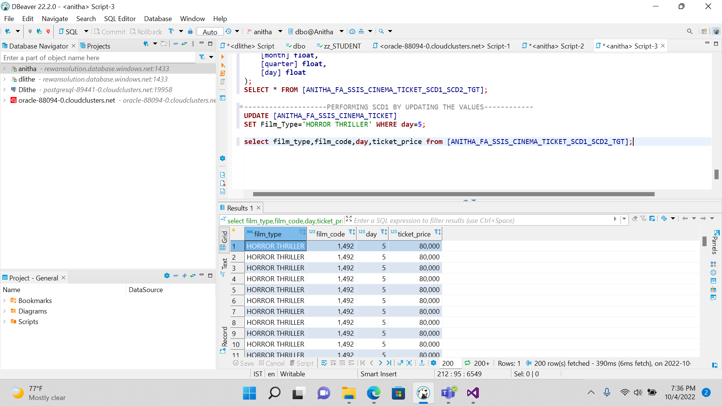

**3. SCD TYPE 2**

**We Get execution result along with historical result.**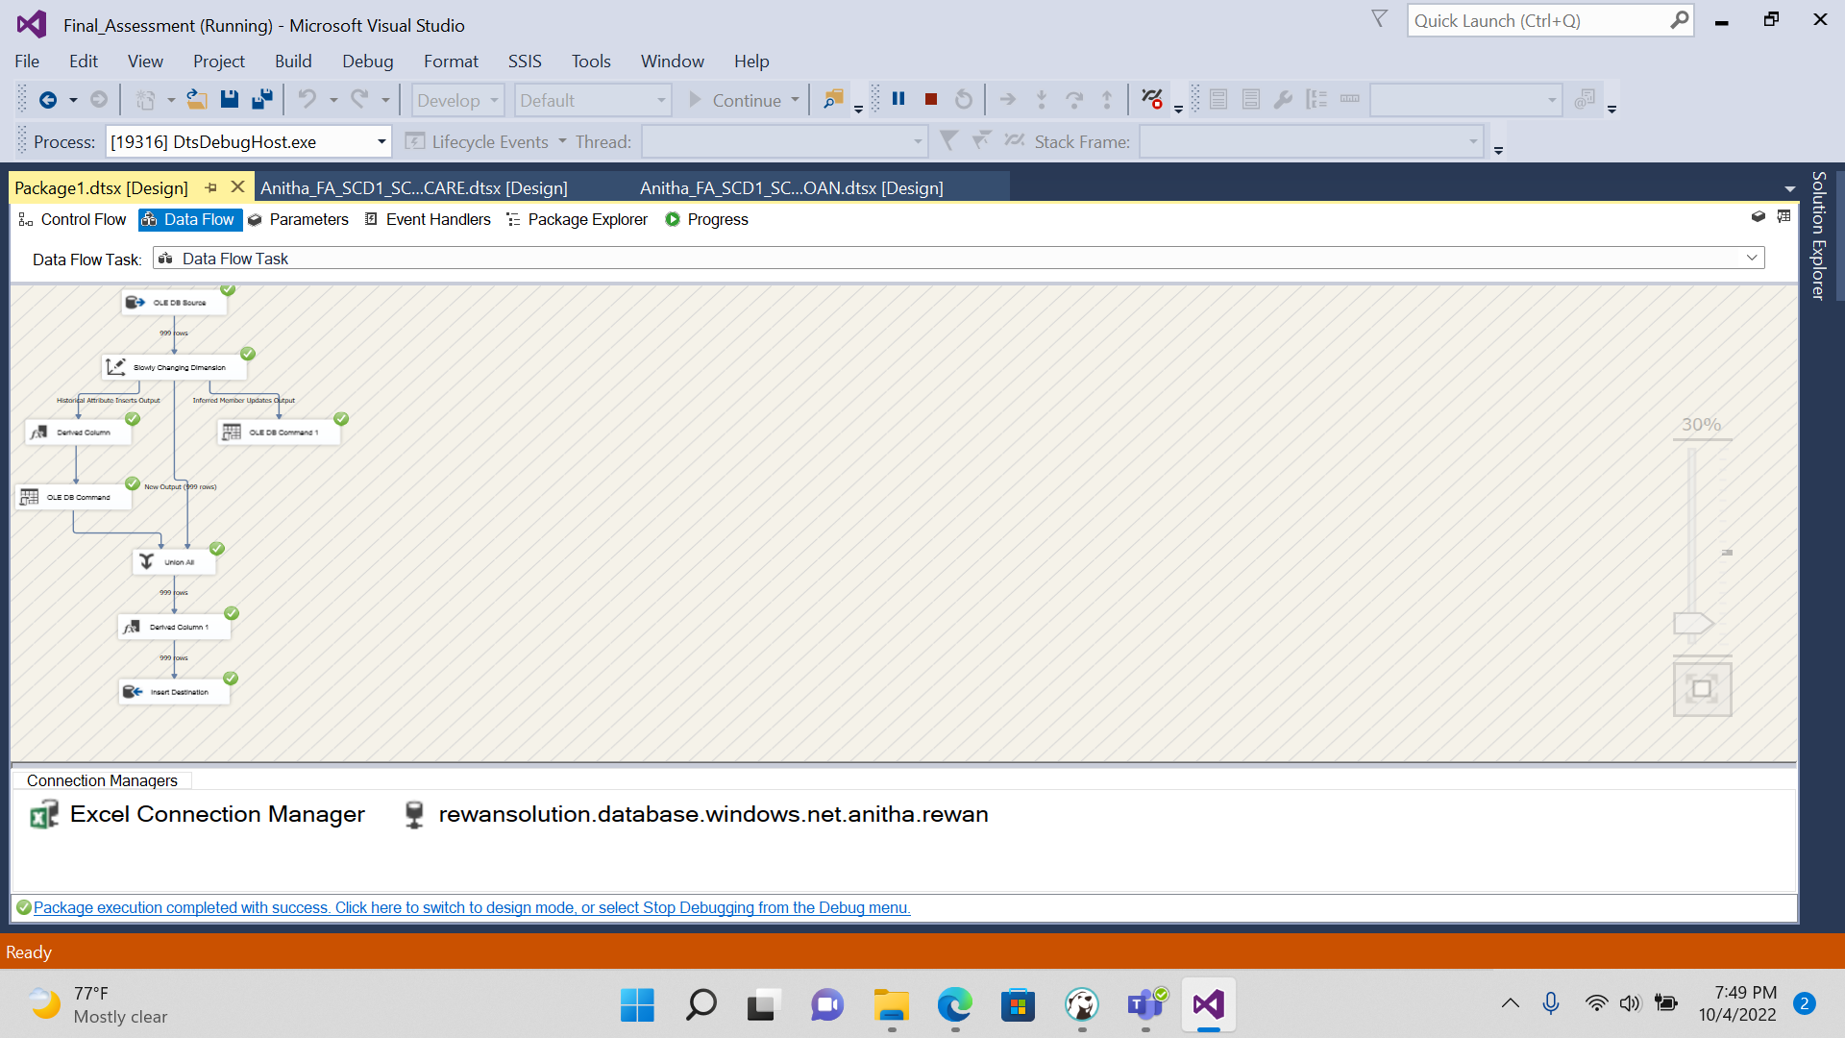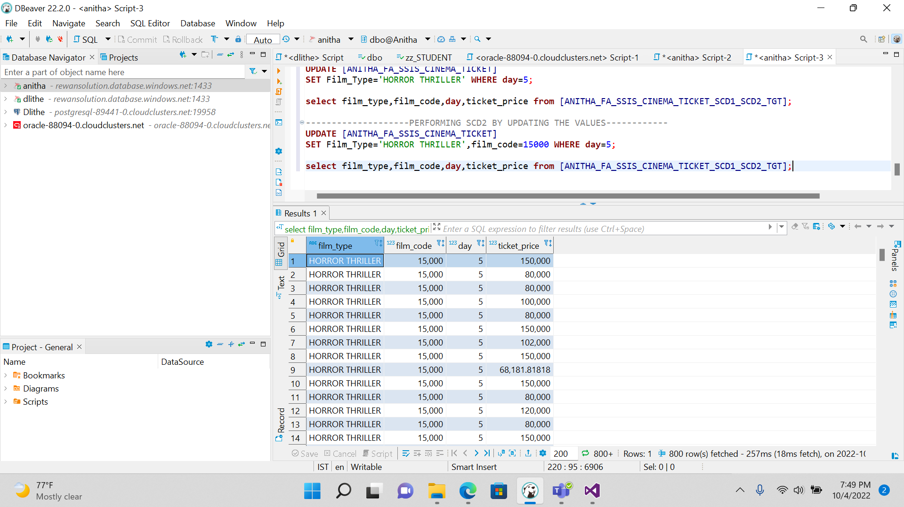

**4.CREATING AGGREGATE BASED ON THE DAY COLUMN**

**FINDING THE COUNT OF DAY REFERRING TO CINEMA TICKET TABLE**

